Getting Started Document

* The repository is at <https://github.com/ProjectDataClarity/SurfaceDerivedData> Click on this link to go to the repository page. Click on the **Download ZIP** button and save the file to your desktop, and extract it. On the same page, you can directly explore the code by clicking on the links.
* If you have Matlab skip to the next step. Otherwise download and install Octave from this website. <https://www.gnu.org/software/octave/index.html>
* Open Octave GUI or Matlab. Make the Current directory, the directory where the files are. Then type one of the following into the command window.
  + output = computeROPApproach1;
  + output = computeBitDepthApproach1;

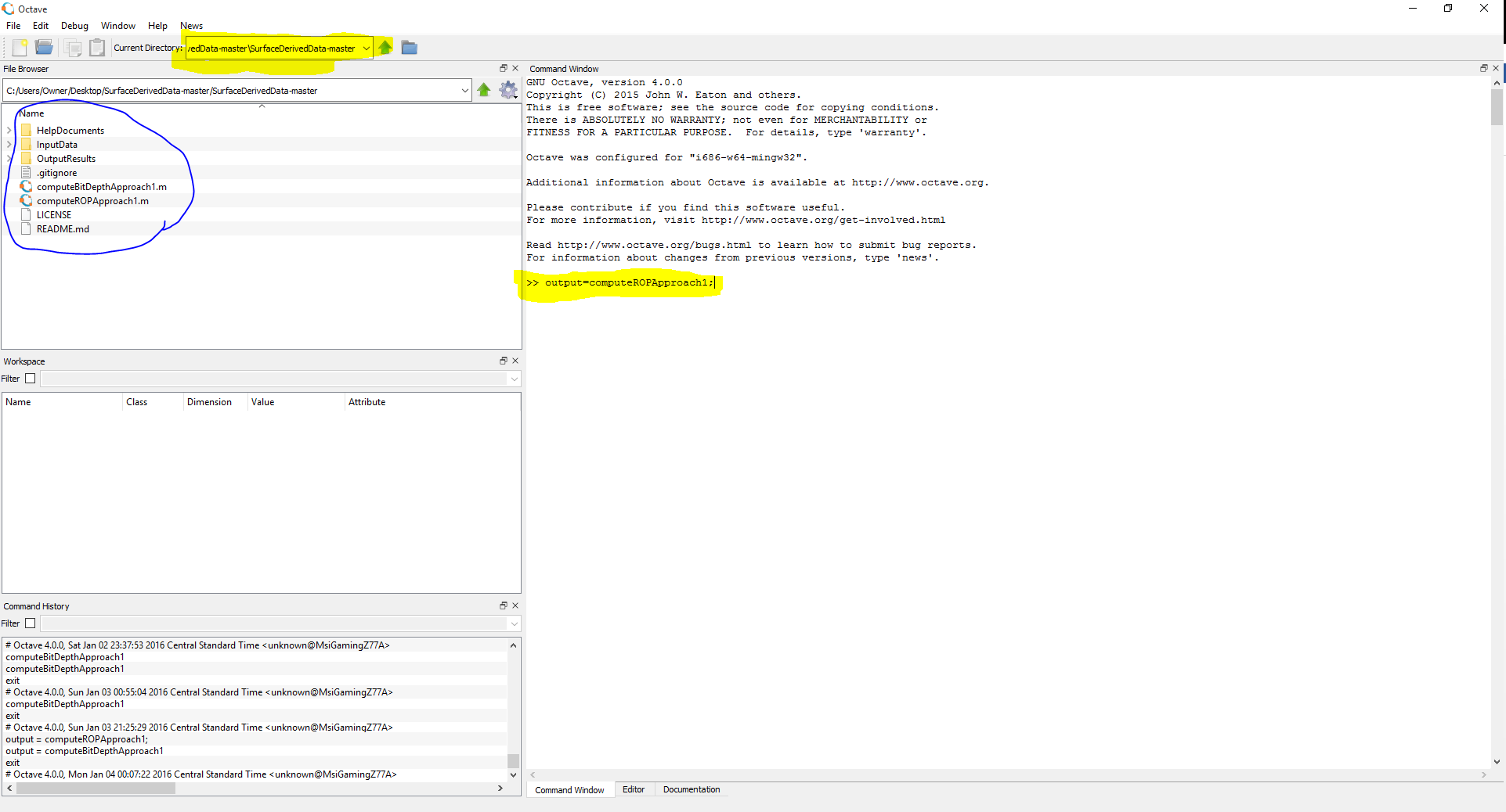

* There are three folders in the repository. InputData, OutputResults and HelpDocuments. The main computational code files are in the root folder.
* The input data folder has two files: SampleData1 and RigStatesForSampleData1. The commands load “SampleData1” or load “RigStatesForSampleData1”, can be used to load the data into the work space.
* SampleData1 contains 8 columns of 50,000 1Hz data. The data being; Block Height(feet),Flow Out(%), Hookload(klbf), Top Drive Speed(RPM), Strokes Per Minute #1, Strokes Per Minute #2, Standpipe Pressure (psi) and Top Drive Torque (ftlb).
* RigStatesForSampleData1 contains the rig states corresponding to these 50,000 data points. The following WITS0 Activity Code is used. Ref:http://home.sprynet.com/~carob/appe.htm

|  |  |  |
| --- | --- | --- |
| **Code** | **Activity** | **Description** |
| 0 | Undefined Status | Anything not covered by other activity codes. |
| 2 | Drilling | The process of making new hole. |
| 3 | Connection (drilling) | The process of adding a joint of drillpipe to the string. |
| 4 | Reaming | Return to total depth with pumps on, pipe rotating and/or weight on bit. |
| 7 | Condition and/or Circulate mud | Pumps on with pipe turning slowly and/or some pipe reciprocation and/or no weight on bit and no increase in total depth. |
| 8 | Tripping In | The act of running the drillstring into the hole. |
| 9 | Tripping Out | The act of pulling the drillstring from the hole. |

* The compute*.m files are split into 4 distinct sections. The first part of the program load the required data. The second part does the computation. The third part write the results to a csv file, and the fourth part plot the data.
* The CSV files are saved in the OutputResults folder for further analysis. A spotfire template is also provided for quick visualization of the results beyond Octave and Matlab.